Ideation Phase
Define the Problem Statements

Date | 30 June 2026
Team ID
Project Name | Heritage Treasures: An In-Depth Analysis of UNESCO World Heritage Sites in Tableau
Maximum Marks | 2 Marks

Customer Problem Statement Template:
Create a problem statement to understand your customer's point of view. The Customer Problem Statement template helps you focus on what matters to create experiences people will love.
A well-articulated customer problem statement allows you and your team to find the ideal solution for the challenges your customers face. Throughout the process, you’ll also be able to empathize with your customers, which helps you better understand how they perceive your product or service.

Reference: https://miro.com/templates/customer-problem-statement/
Example:
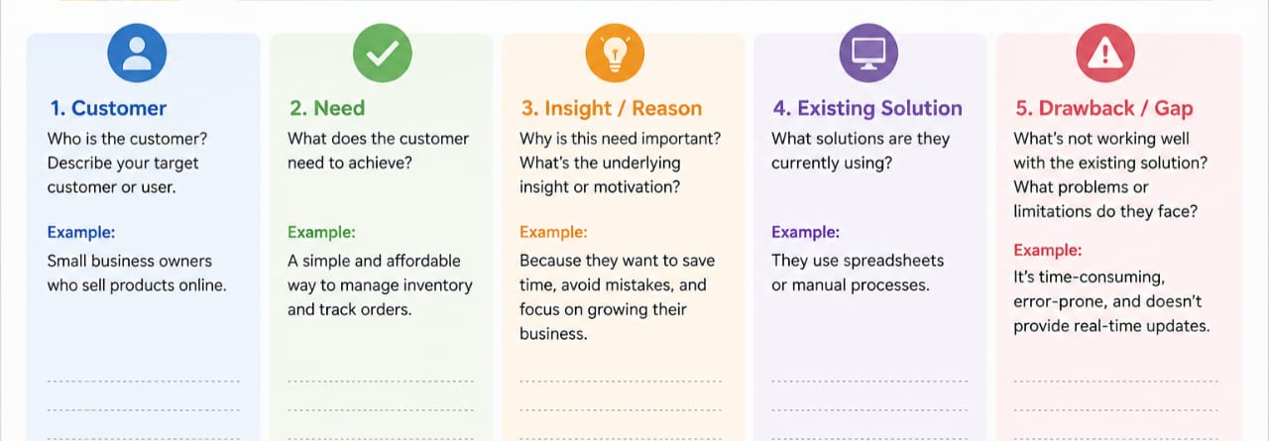
Problem Statement (PS) | I am (Customer) | I’m trying to | But | Because | Which makes me feel
PS-1 | A heritage conservation researcher. | Identify which UNESCO sites are most at risk across regions. | The data is spread across disconnected PDFs and spreadsheets. | There is no unified visual analytics tool for World Heritage Site data. | Frustrated and inefficient in prioritizing conservation work.
PS-2 | A tourism policy planner. | Understand how heritage site inscriptions are trending by region. | I cannot easily compare historical patterns across countries. | The available data is static and not interactive. | Unable to make timely, evidence-based decisions.

